Convert the following binary numbers into hexadecimal:

- 1 1 0 0 0 0 1 1
- 1 1 1 1 0 1 1 1
- 1 0 0 1 1 1 1 1 1 1
- 1 0 0 1 1 1 0 1 1 1 0
- 0 0 0 1 1 1 1 0 0 0 0 1
- 1 0 0 0 1 0 0 1 1 1 1 0
- 0 0 1 0 0 1 1 1 1 1 1 1 0
- 0 1 1 1 0 1 0 0 1 1 1 0 0
- 1 1 1 1 1 1 1 1 0 1 1 1 1 1 0 1
- 0 0 1 1 0 0 1 1 1 1 0 1 0 1 1 1 0

Convert the following hexadecimal numbers into binary:

- 6 C
- 5 9
- A A
- A 0 0
- 4 0 E
- B A 6
- 9 C C
- 4 0 A A
- D A 4 7
- 1 A B 0

Convert the following hexadecimal numbers into denary:

- 6 B
- 9 C
- 4 A
- F F
- 1 F F
- A 0 1
- B B 4
- C A 8
- 1 2 A E
- A D 8 9

Convert the following denary numbers into hexadecimal:

- 9 8
- 2 2 7
- 4 9 0
- 5 1 1
- 8 2 6
- 1 0 0 0
- 2 6 3 4
- 3 7 4 3
- 4 0 0 7
- 5 0 0 0

Using software on your computer (for example, text colour option in Word), find out what colours would be represented by the following RGB denary value combinations:

- Red 53
Green 55
Blue 139

- Red 201
Green 122
Blue 204

- Red 12
Green 111
Blue 81

Convert each of the above denary numbers into hexadecimal.

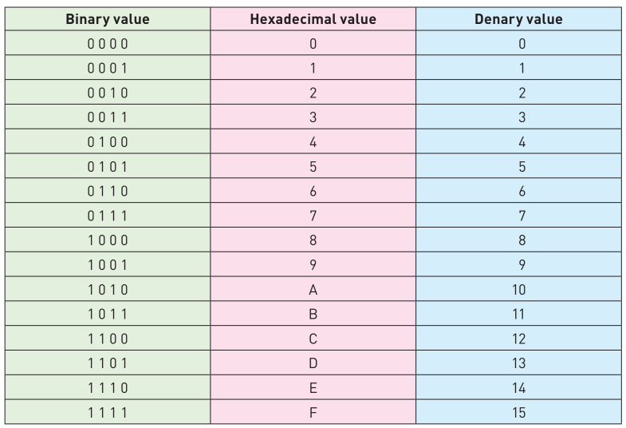
Hexadecimal to denary:
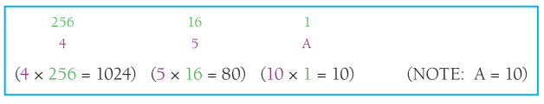
Denary to Hexadecimal:
